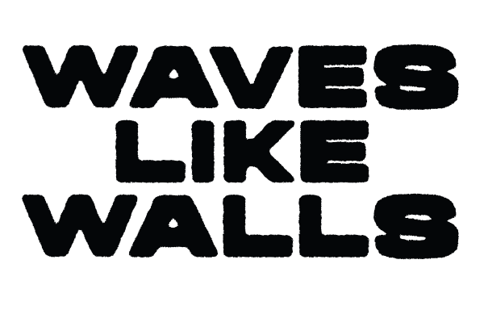
What Ingolstadt-based band Waves Like Walls have created since they started goes far beyond music. Their authentic approach, clear values, and lively interaction with their fans, has not only built a steadily growing community. Through their music they have built a movement. A movement that has become far more than the sum of its parts, thanks to their authentic lyrics, which offer their audience a deep relatability and connection. Driven by their goal of combining musical intensity with honest emotions, they have developed something unique. A sound that constantly evolves with modern, energetic and emotional aspects of hardcore and metalcore. However, there’s one aspect of Waves Like Walls’ music that excites fans the most: their energetic live shows, where their big, memorable melodies, heavy riffs, and profound lyrics captivate the audience from the very first second. This has clearly established Waves Like Walls’s name within the German underground scene, where they launched their own festival – the Family And Friends Fest, that they’ve sold out for the first time in 2026 with over 500 attendees. After touring with Hatebreed and opening for genre giants like Stray From The Path, Lionheart, and Crystal Lake, the Ingolstadt-based band has long since secured a spot in lineups of festivals such as Summer Breeze, Farewell Youth, and Traffic Jam.
When matters mean more than any trends or success true authenticity emerges. With attitude and clear values, German heavy-hitters Waves Like Walls convey said authenticity from their early days in 2012 on with an approachable energy that captivates their audience without any circumstances. The Ingolstadt-based band developed a melodic hardcore sound enthralls with unfiltered lyrics and moving melodies that go deep under the skin. Said approach was already established on their EPs “Brain As A Weapon” (2013) and “The Path” (2016) as well as their debut album “Waves Like Walls” (2020) but intensified on their latest body of work “It Never Ends” that redefined their sound with modern sound aspects and heavier influences. This has fostered a close bond with their community – one that also appreciates the band’s trueness to themselves and is driven by Waves Like Walls’ ambition to reflect their musical roots - no matter how big their stages get. Following a tour with Hatebreed and support slots for Stray From The Path, Lionheart, and Crystal Lake in December 2025, Waves Like Walls got signed by Golden Tides / Uncle M and released two new singles: “They Preach, We Burn” feat. Dead Like Juliet – a social-commentary single, as well as their current single “Never Enough” that features Richard Lardner (Downpour, ex-Lock & Key). At the pinnacle of their creativity, Waves Like Walls keep delivering their blend of raw, energetic and modern hardcore music and hints on what is to come from this powerhouse in future.

