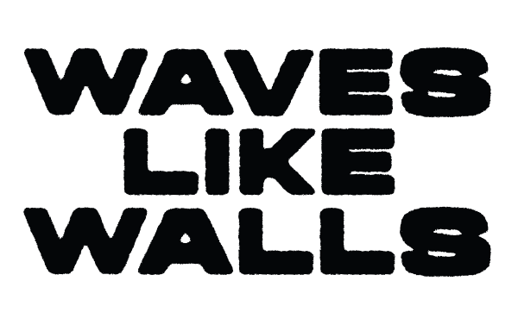
When matters mean more than any trends or success, true authenticity emerges. With attitude and clear values, German heavy-hitters Waves Like Walls convey said authenticity with an approachable energy that captivates their audience without any circumstances. On both of their EPs and albums as well as live shows, their energetic and melodic hardcore sound enthralls with unfiltered lyrics and moving melodies that go deep under the skin. This has fostered a close bond with their community – one that appreciates the band’s trueness to themselves and is driven by Waves Like Walls’ ambition to reflect their musical roots - no matter how big their stages get. Following a tour with Hatebreed and support slots for Stray From The Path, Lionheart, and Crystal Lake in December 2025, Waves Like Walls got signed by Golden Tides / Uncle M and released two new singles. In 2026, the band continues to celebrate its firm values at their own sold-out festival (Family And Friends Fest) as well as on performances at Summer Breeze, Farewell Youth, and Traffic Jam Open Air. More is to come.

